**WEEK-9 Tutorial (ICT502)**

**Student ID: S20241757**

**Student Name: RAHUL TUNDIYA**

Create a database for your website that has a table and includes information such as username, password, first name, last name, age, country.

Also create a login page in your website that receives username and password from the user and through SQL command check whether the username and password are correct or not. If they are correct, redirect the user in a welcome page and demonstrate the heading of Welcome to my page. Otherwise, showing the message Invalid username or password.

Take the screenshot of your code here:

Login.php

<!DOCTYPE html>

<html lang="en">

<head>

<meta charset="UTF-8">

<meta name="viewport" content="width=device-width, initial-scale=1.0">

<title>Login</title>

<style>

body {

margin: 0;

padding: 0;

display: flex;

justify-content: center;

align-items: flex-start;

min-height: 100vh;

background-color: #FFF9D0;

}

.parent {

min-width: 500px;

font-family: Arial, sans-serif;

font-size: 16px;

background-color: #CAF4FF;

padding: 20px;

border-radius: 8px;

box-shadow: 0 4px 8px rgba(0, 0, 0, 0.1);

}

.parent form {

display: flex;

flex-direction: column;

align-items: center;

}

.parent form div {

display: flex;

flex-direction: row;

gap: 10px;

align-items: center;

margin-bottom: 20px;

}

.parent label {

margin-bottom: 5px;

}

.parent input[type="text"],

.parent input[type="password"] {

width: 100%;

padding: 10px;

border: 1px solid #ccc;

border-radius: 4px;

box-sizing: border-box;

}

.parent input[type="submit"],

.parent input[type="reset"] {

width: 100%;

padding: 10px;

border: none;

border-radius: 4px;

cursor: pointer;

font-size: 18px;

margin-bottom: 5px;

}

.parent input[type="submit"] {

background-color: #5AB2FF;

color: black;

}

.parent input[type="submit"]:hover,

.parent input[type="reset"]:hover {

background-color: #4993d4;

}

.error {

color: red;

margin-top: 10px;

text-align: center;

}

</style>

</head>

<body>

<div class='parent'>

<form action="#" method='POST'>

<h3>LOGIN PAGE</h3>

<?php if ($_SERVER['REQUEST_METHOD'] == 'POST' && (!isset($result_row) || mysqli_num_rows($result) <= 0)) { ?>

<p class="error">Re-enter correct username and password.</p>

<?php } ?>

<div>

<label for="name">Username</label>

<input type="text" name="username" id="name">

</div>

<div>

<label for="pass">Password</label>

<input type="password" name="password" id="pass">

</div>

<div>

<input type="reset" value="Cancel" />

<input type="submit" value="Login">

</div>

</form>

</div>

<?php

//mysqli procedural

$server = "localhost";

$dbuser = "root";

$dbpassword = "";

$dbname = "myUsers";

//----- Session -----//

session_start();

// 1. Create a connection to the database

$con = mysqli_connect($server, $dbuser, $dbpassword, $dbname);

if ($con->connect_errno) {

die("Connection Failed " . mysqli_connect_errno());

}

if ($_SERVER['REQUEST_METHOD'] == 'POST') {

$dbuser_name = $_POST['username'];

$password = $_POST['password'];

$query = "SELECT * FROM users WHERE username='" . $dbuser_name . "' AND password='" . $password . "'";

$result = mysqli_query($con, $query);

// Check if the query was successful and if there's a row

if ($result && mysqli_num_rows($result) > 0) {

$result_row = mysqli_fetch_array($result);

$_SESSION["username"] = $dbuser_name;

$_SESSION["type"] = $result_row['user_type'];

header("location:user.php");

}

}

?>

</body>

</html>

user.php

<?php

session_start();

if (!isset($_SESSION["username"])) {

header("location:login.php");

}

?>

<!DOCTYPE html>

<html>

<head>

<meta charset="UTF-8">

<meta name="viewport" content="width=device-width, initial-scale=1.0">

<title>User Profile</title>

<style>

body {

margin: 0;

padding: 0;

display: flex;

justify-content: center;

align-items: flex-start;

height: 100vh;

background-color: #FFF9D0;

}

.container {

font-family: Arial, sans-serif;

font-size: 16px;

background-color: #CAF4FF;

padding: 20px;

border-radius: 8px;

box-shadow: 0 4px 8px rgba(0, 0, 0, 0.1);

text-align: center;

}

.container h1 {

margin-bottom: 20px;

}

.container button {

padding: 10px 20px;

border: none;

border-radius: 4px;

background-color: #FF70AB;

color: black;

font-size: 18px;

cursor: pointer;

color: #f5f5f5;

}

.container button:hover {

background-color: #d05c8c;

}

</style>

</head>

<body>

<div class="container">

<h1>Welcome to <?php echo $_SESSION["type"] . " page, " . $_SESSION["username"]; ?></h1>

<button onclick="location.href='login.php'">Sign out</button>

</div>

</body>

</html>

Take screen shots of the successful and unsuccessful login attempts:

Unsuccessful

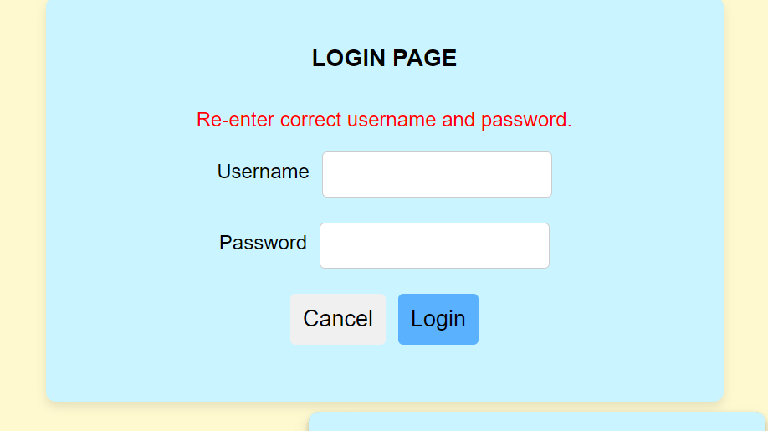

Successful:

